**ASSIGNMENT – 19.2**

**Problem Statement:**

Convert XML File into Json File Format. You can consider below example XML, save it in the hdfs cluster and then to convert into Json File Format.

<property>

<name>fs.default.name</name>

<value>hdfs://localhost:9000</value>

</property>

<property>

<name>Namenode</name>

<value>hdfs:50070</value>

</property>

<property>

<name>Job Tracker</name>

<value>hdfs:50030</value>

</property>

**Input:**

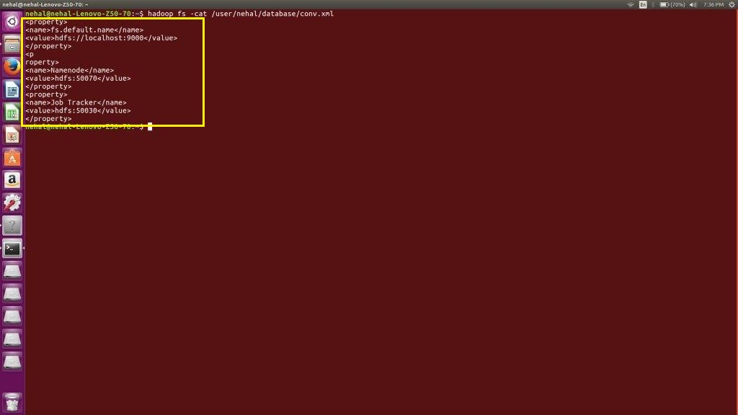

**Program:**

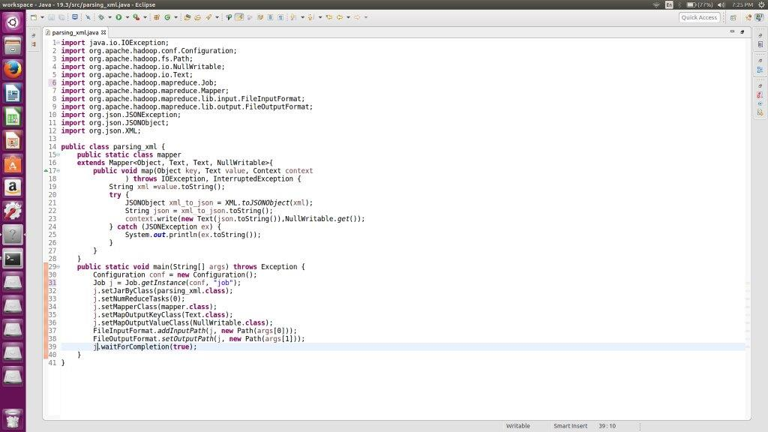

**Output:**

